User Interface (UI):

PyQt was used for UI. PyQt is a set of Python bindings for Qt application framework from Qt Company.

The UI has two parts: main window and sub windows.

**Main window:**

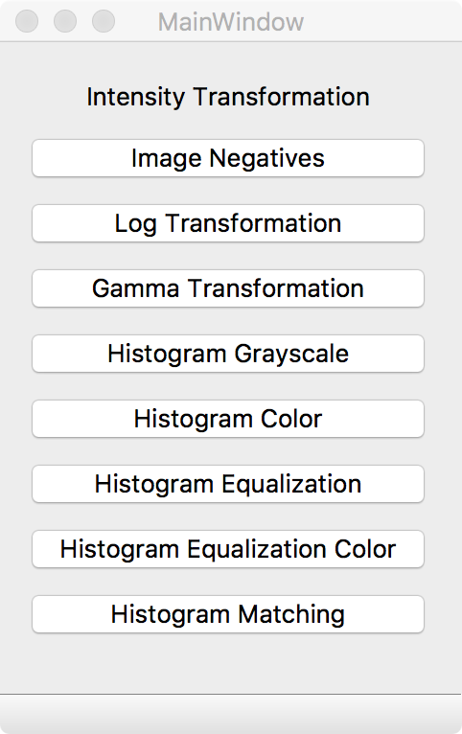

User can select the transformation by clicking on one of the buttons on main window.

Then a **sub window** will show up as below:

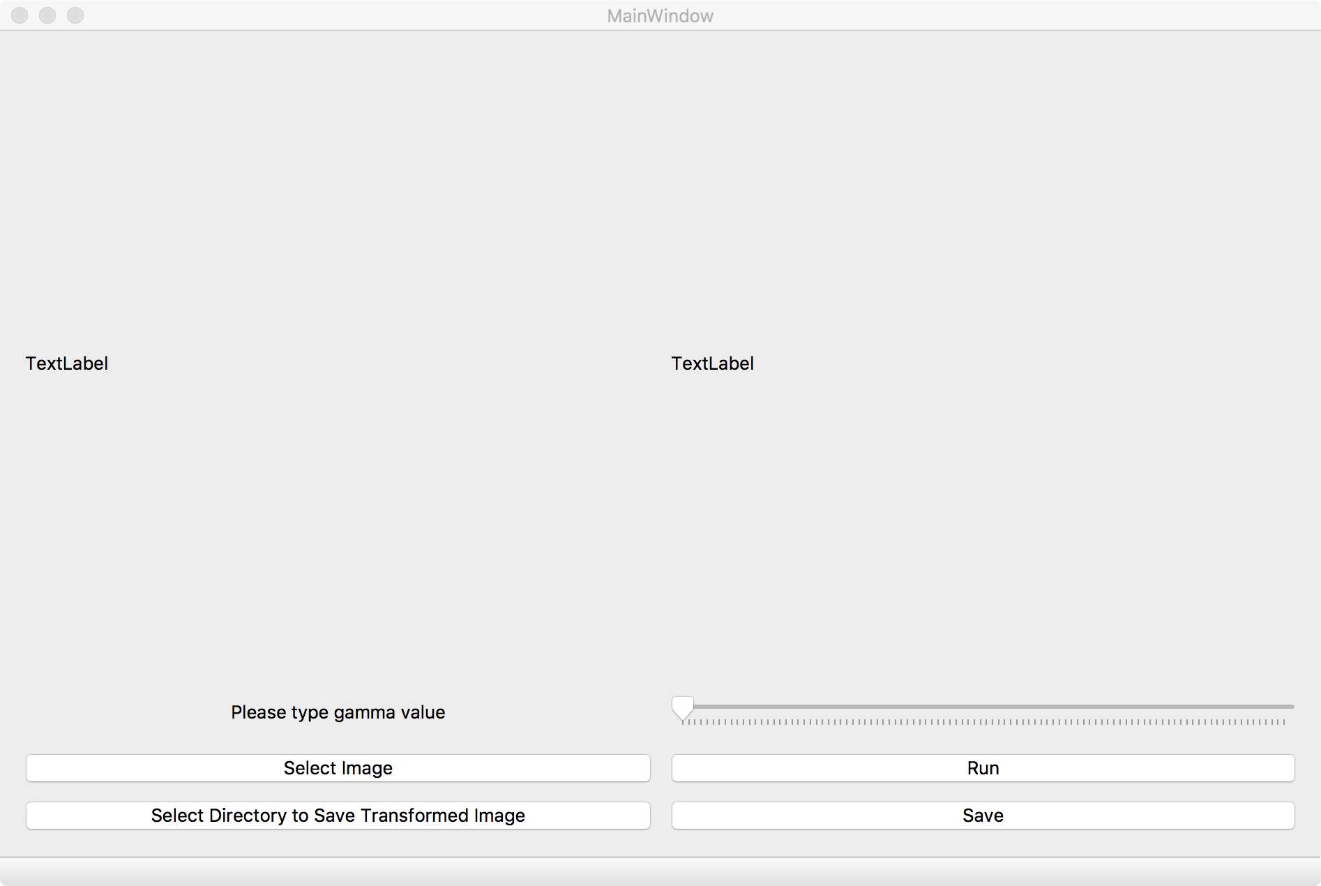

The layout and buttons varies according to the type of transformation.

The program is multi-threaded and multiple sub windows can be opened at the same time

Logarithmic Transformation:

Objective:

Logarithmic transformation is used to brighten the intensity of image. It is more often used to increase the detail of lower intensity values.

Algorithm:

1. The image is loaded into a matrix as f
2. Transformed image will be saved as matrix l
3. Formula for logarithmic transformation:

l = c * log(1+double(f))

1. c is a constant used to scale the range of log function to match input domain. As we are working with 8 bit image(type of uint8), so c = 255/log(1+255) is used for this case.

Results:

Select ‘Log Transformation’ from main UI window

Below screenshot shows a sample output of log transformed images.

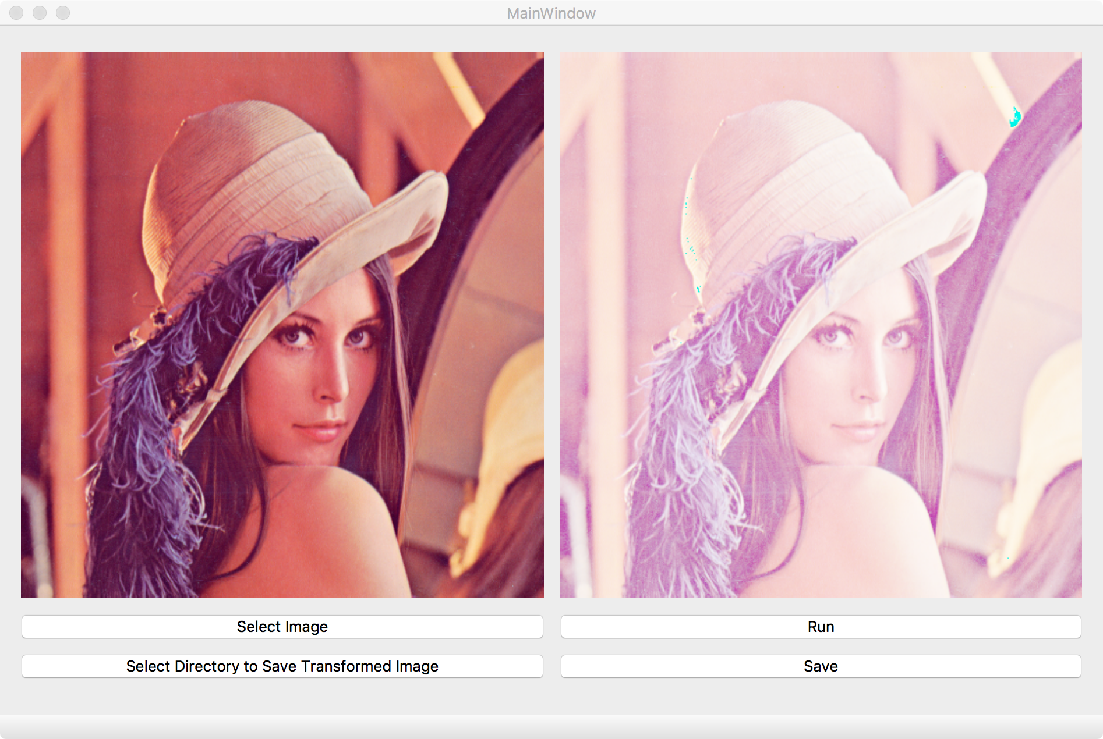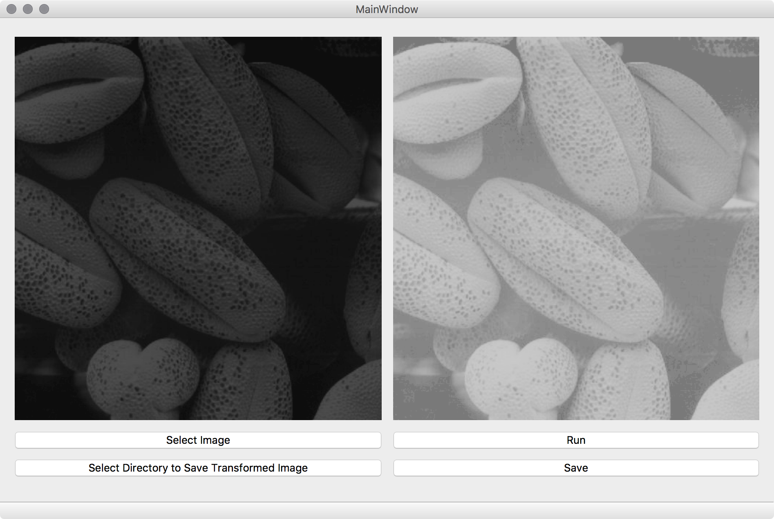

Image Negative:

Objective:

Image negative is the process of reproduce the bright portion of photographed subject as dark and dark parts as light areas. Negative was commonly on a strip or sheet of transparent plastic film and when the negatives are projecting onto paper or a screen, it restores light and dark to their normal order.

Algorithm:

1. The 8 bit image(type of uint8) was first loaded into matrix f
2. Transformation image will saved as matrix g
3. 8 bit image with intensity values in the range 0 to 255
4. The formula for converting negatives:

g = 255 – f

Results:

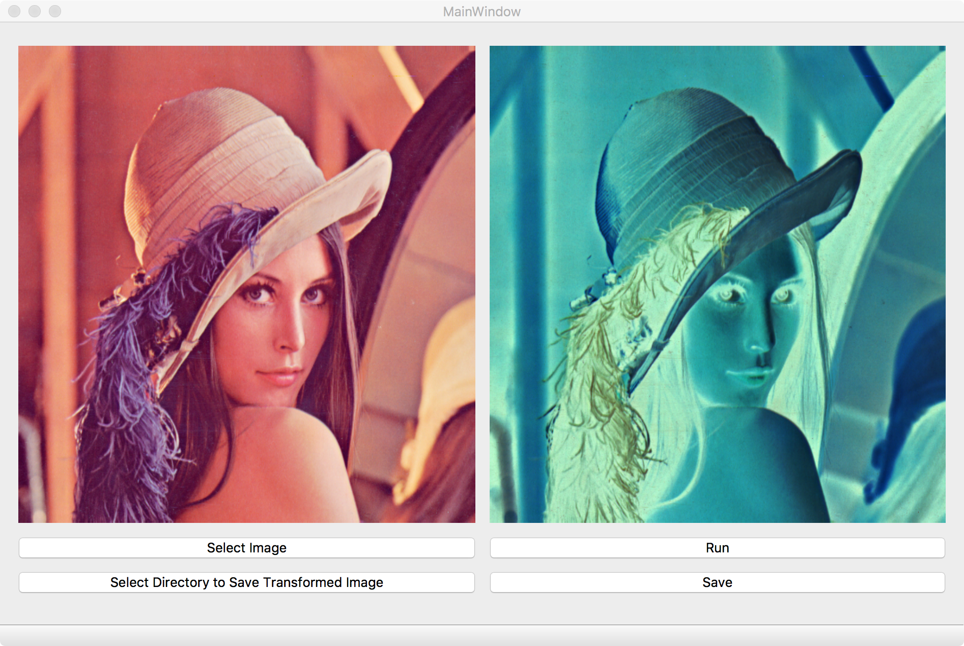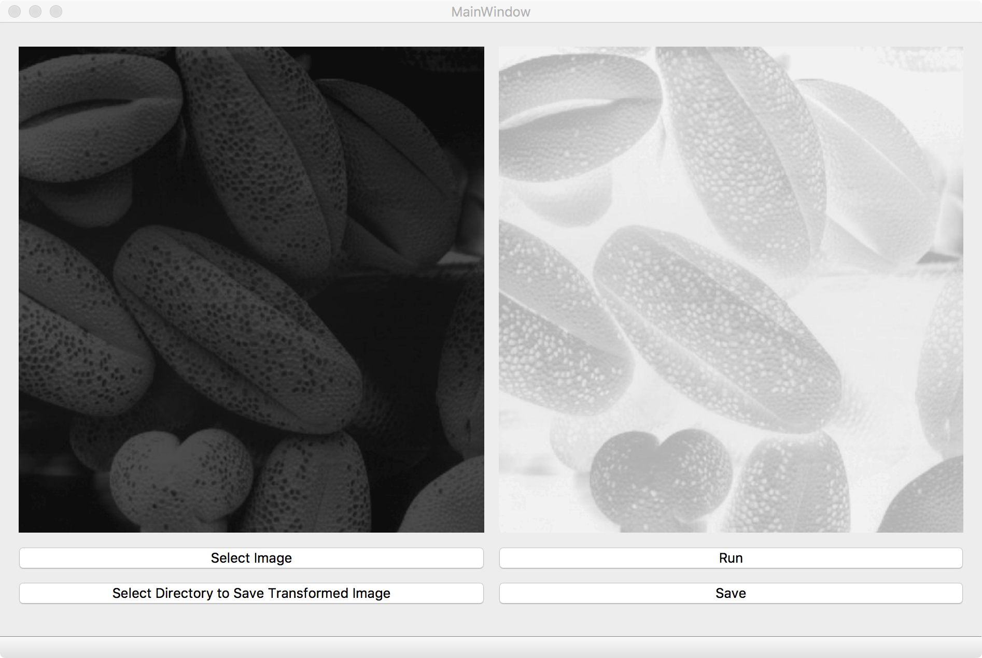

Histogram:

Objective:

Image histogram is a graphical representation of intensity distribution. It plots the number of pixels for each intensity value. Histogram is able to help to judge the entire intensity distribution at a glance.

Algorithm:

1. The 8 bit image(type of uint8) was first loaded into matrix f
2. An integer array with size of 256 was created as h
3. Image will be iterated pixel by pixel to count the occurrence of every pixel intensity
4. the data will be graph with intensity value as X vs number of occurrence of intensity level as Y
5. for colored image, same process was done for every color channel

Result:

